**Creates a file called hello.xhtml that renders a JSF text box, links it to a managed bean to set a property and then display the property in another xhtml file called welcome.xhtml**

1. You can use the same project created in the previous exercise. Add an xhtml file to the WebContent folder.
2. File-> New -> xhtml page. Select “Blank JSF Pages” as the template.

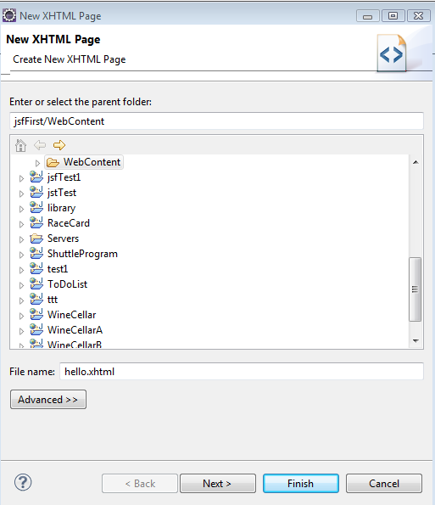

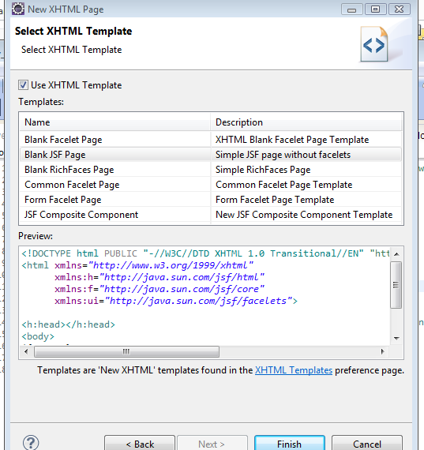

1. Add the following code to hello.xhtml

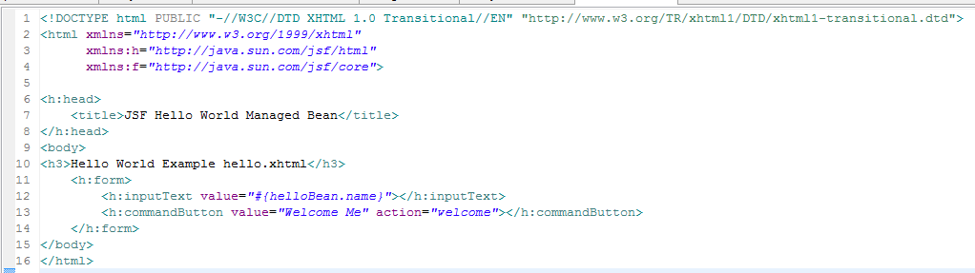

1. Create a new package in the src folder.

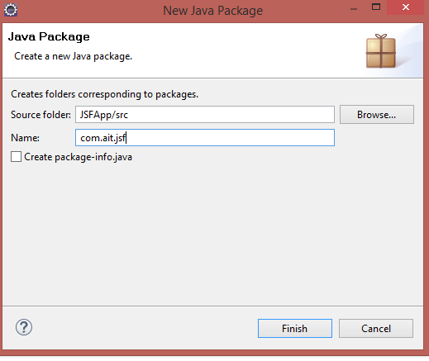

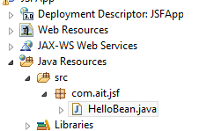

1. Add a new Java Class to the package with the following code

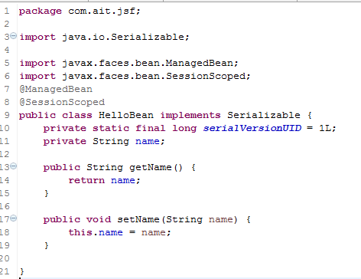

1. Add another xhtml page in the WebContent folder called welcome.xhtml with the following content

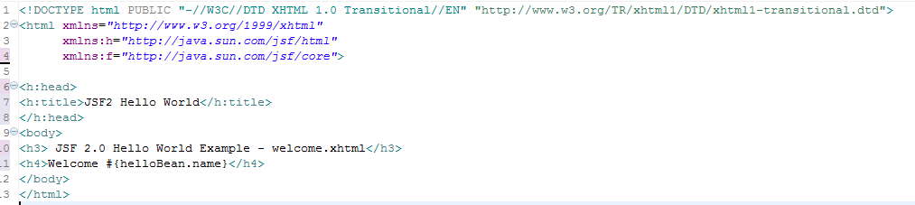

1. Run the project. Navigate to http://localhost:8080/JSFApp/hello.jsf in the browser. You should see the following output.

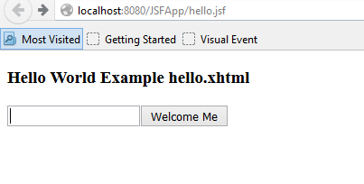

1. Enter a name and press the button. You will get the following output.

